3d-rid – micromachining for radiation imaging detectors*
V. O’Shea
Department of Physics & Astronomy,
University of Glasgow,
Glasgow G12 8QQ, Scotland
E-mail: v.oshea@physics.gla.ac.uk

Recent advances in the technology of micro-machining have enabled novel topologies for radiation detector design to be proposed. This paper will describe some of the work that is being carried out to develope detector structures with enhanced detection efficiency for x-rays, reduced cross-talk and edgeless operation. All of these are essential characteristics of detectors that are needed to make large area arrays (20X40 cm) for x-ray imaging with better performance than the flat panels currently available. Other configurations such as scintillator filled structures and structures filled with other materials will also be described.

Introduction

3D-RID
This project has the objective of applying the recent technological advances in the field of micro-machining to radiation detectors. In order to develop these concepts a number of distinct structures were identified that could lead to potential improvements in detector performance over a wide range of applications from synchrotron studies to medical x-ray imaging.
The principal structures that have been proposed as demonstrators for these techniques are shown schematically in Figure 1. The structures broadly divide into types with closely spaced large pores and thin walls and those with very narrow holes that are spaced widely apart. Three techniques are under investigation within the project to form the physical structures that are required for the various detector types we have proposed. Deep Reactive Ion Etching (DRIE) process development is the core business activity of one of the industrial partners in the project and processes are developed by them to etch deep and narrow holes in both Silicon and Gallium Arsenide in order to fabricate arrays of holes and make a pixellated detector structure.
Figure 1. shows the type of structures that are being studied for the project.
X-ray Photon
Scintillator filled
light guides
2. Integrated pn-junctions
CCD
CsI
Si
Si
ROIC
CsI
+
-
+
-
BC

3. Other materials

4. Direct detection
Si
ROIC
+
-
+
-
BC
ROIC
Incident Radiation
+ -
+ -
BC
Si

The Electro-chemical Etching (EE) process that had been developed for the production of porous Silicon has been adapted to produce precisely controlled etching of a variety of structural features that are of interest to the project. Finally, use has been made of a femto-second pulsed laser to ablate narrow holes in GaAs in order to form detector structures.
Further processing has been developed to dope the machined surfaces and a means of depositing uniform coatings of metal within the very narrow pores has been made available to us from the University of Helsinki.

Motivation
The idea of looking at these types of structures was proposed as a possible way of increasing the radiation hardness of Silicon sensors up to the level of 10¹⁵ 1 Figure 2. shows the classic planar structure illustrating the detection mechanism and charge drift path for this configuration.
h
+
e
-
E
-ve
+ve
n
n
+
p
+
-ve
-ve
W_{2D}
x_{2D}
ionising radiation

MeV neutron equivalent cm⁻² by Parker et al. [1], for applications in experimental high energy physics. The greatly reduced collection distance for the generated charge would considerably enhance the radiation resistance of the sensor elements. The depletion of such a vertical structure depends on the spacing between the holes i.e. for 50 μm pixels the depletion distance would be 25 μm. Similarly the path length that the charge must drift laterally to reach the collection electrodes is of a comparable order.

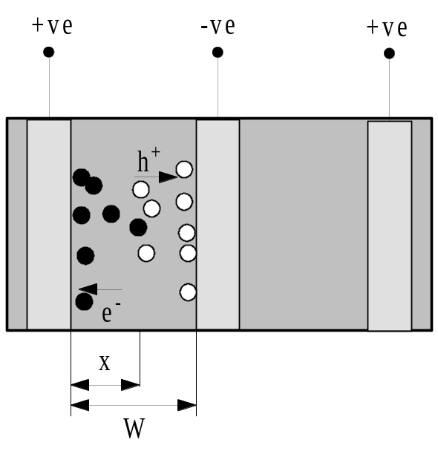
Figure 3. shows the proposed structures and how the device is configured. The lateral depletion and charge drift are among the attractive features of this arrangement.
E
3D
3D

Simulation of this sort of configuration for various pixel sizes has been done using both ISE and MEDICI. Devices on Si of different resistivities have depletion voltages listed in the Table 1 irrespective of the detector thickness. The fact that the depletion region grows laterally between electrodes also means that the guard ring structures traditionally used to reduce the dead detection volume at the edges of the detector do not need to be used for this type of structure. This means that detectors of reasonable thickness can be fabricated in this technology with negligible dead zones around the periphery. This is a very important attribute when the goal is to make large area imaging plates for medical and synchrotron applications.
Table 1. Simulation results for the values of depletion voltages for 3-D structures using MEDICI for various pixel sizes and different residual doping levels of the starting material.

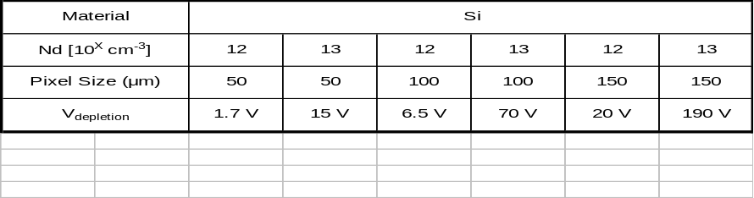
The fact that the collection electrode is actively screened the by the outer electrodes in this geometry also means that charge sharing is virtually eliminated by using this geometry. In tests with photon counting readout on planar detector with a pencil beam at the ESRF in Grenoble the low energy tail on a diffuse beam shown in Figure 4 disappears when the beam is focused in the centre of the 55 μm square pixel.
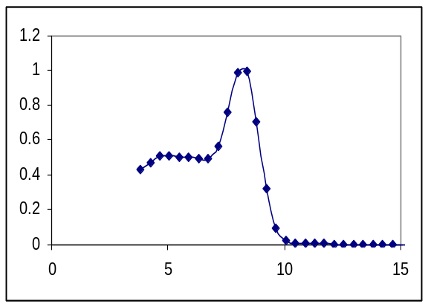

Figure 4. The recorded energy spectrum of a monochromatic X-ray beam at 8 keV without compensation for charge sharing as seen by a single photon counting readout. The plateau to the left of the peak represents shared events (Courtesy of the Medipix [2] collaboration)

The reduced charge sharing and edgeless detection features exhibited by detector based on this technology make them ideal candidates for use in large area tiled arrays for x-ray imaging applications. Much work is being undertaken in related projects [3] to build up the necessary expertise in associated technologies like interconnection and chip design in order to achieve the expertise necessary to build such panels.

Etching techniques and structures
Three techniques have been employed to mechanically form the structures that are of interest to us. Each will be described in the following sections along with the respective advantages and limitations of the process with respect to the performance of the devices we wish to fabricate.

Deep Reactive Ion Etching (DRIE)

This technique is capable of defining very deep and precisely defined etched patterns in silicon. The process used is based on an Inductively Coupled Plasma (ICP) machine developed by STS [4] specifically for the purpose of etching deep structures in silicon and GaAs. The technique makes use of two separate process chambers – the first for etching and the second for a teflon based passivation. The sample is mechanically switched between the two chambers so that the walls of the etched structures may be passivated on alternate cycles of the machine. The plasma creates an ionised etch species (typically Fl for Si and Cl for GaAs) which are accelerated to the exposed surfaces of the sample. The surfaces orthogonal to the accelerated ions are etched preferentially to the side-walls and so the passivation cycle eliminates any taper of the etched structure.
While this technique is excellent for producing these deep structures there is a fundamental limitation to the depth that it can drill which is related to the diameter of the structure. The aspect ratio (depth to diameter) is limited in this process to a little under 20:1 because the process needs to have a certain density of ionised etchant species at the bottom of the hole in order to be sustained. At larger pore depths with small diameters the density of etchant species at the top of the hole is such that the mask is quickly eroded and the process loses definition.
The micrographs shown in Figure 5 show narrow pores that have been etched with this technique. Close inspection of the side-walls show a scalloped effect due to the switched nature of the process.
One of the advantages of this process is that it does not depend on the initial state of the sample. This permits one to drill one set of pores, process them further (i.e. dope and/or fill with other material) and then come back and drill another set of hole that one might chose to dope with the opposite polarity.
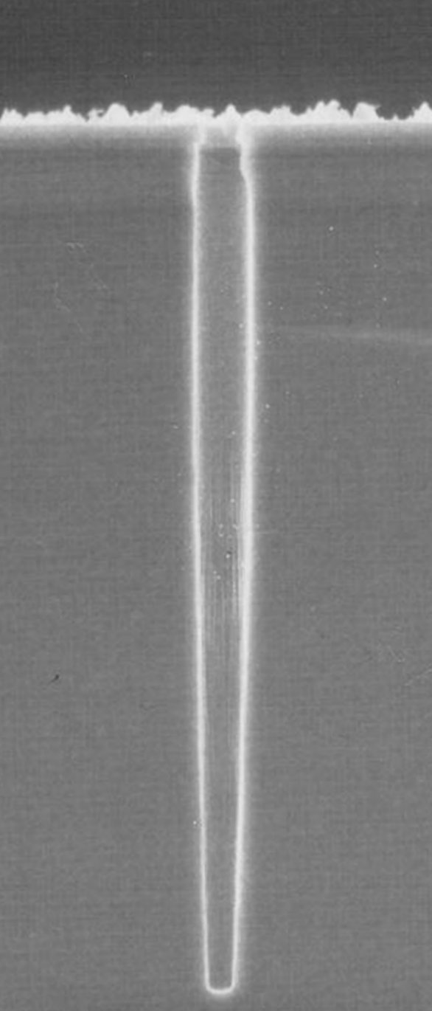
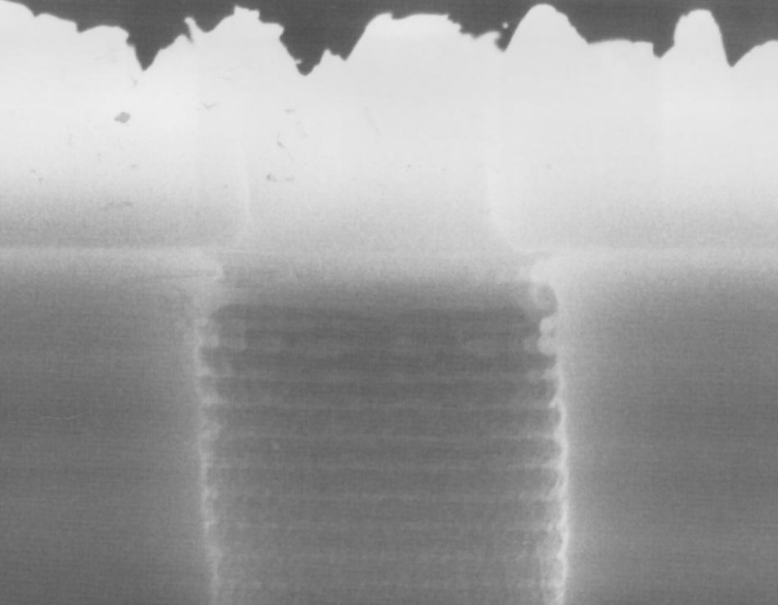

Figure 5. 10μm diameter pore 186 μm deep etched with a DRIE process. The magnified view on the left shows the scallop effect on the side-walls which is characteristic of the switched process used to make these pores.

Electro-chemical Etching
An alternative method for fabricating a wide variety of deep structures in Silicon is known as electro-chemical etching. The surface to be etched is patterned with a series of initiating dimples which are formed with a KOH etch. This is an etch that etches along the crystallographic axis to the substrate with very high selectivity. The sample is then biased from the back across a dilute solution of HF that does not etch silicon in the absence of free carriers. A light source is exposed on the back surface of the sample that creates carriers. These drift across the bulk of the substrate and, as they approach the top surface are focused by the localised electric filed so that they emerge only at the tip of the dimple. A very precisely controlled and localised etching of the silicon then takes place at this point. Figure 6 illustrates the process and a variety of the structures that may be achieved using this process.

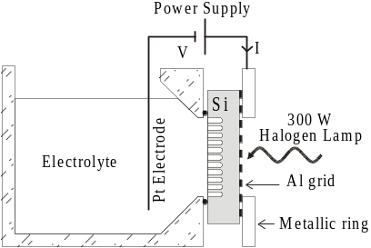
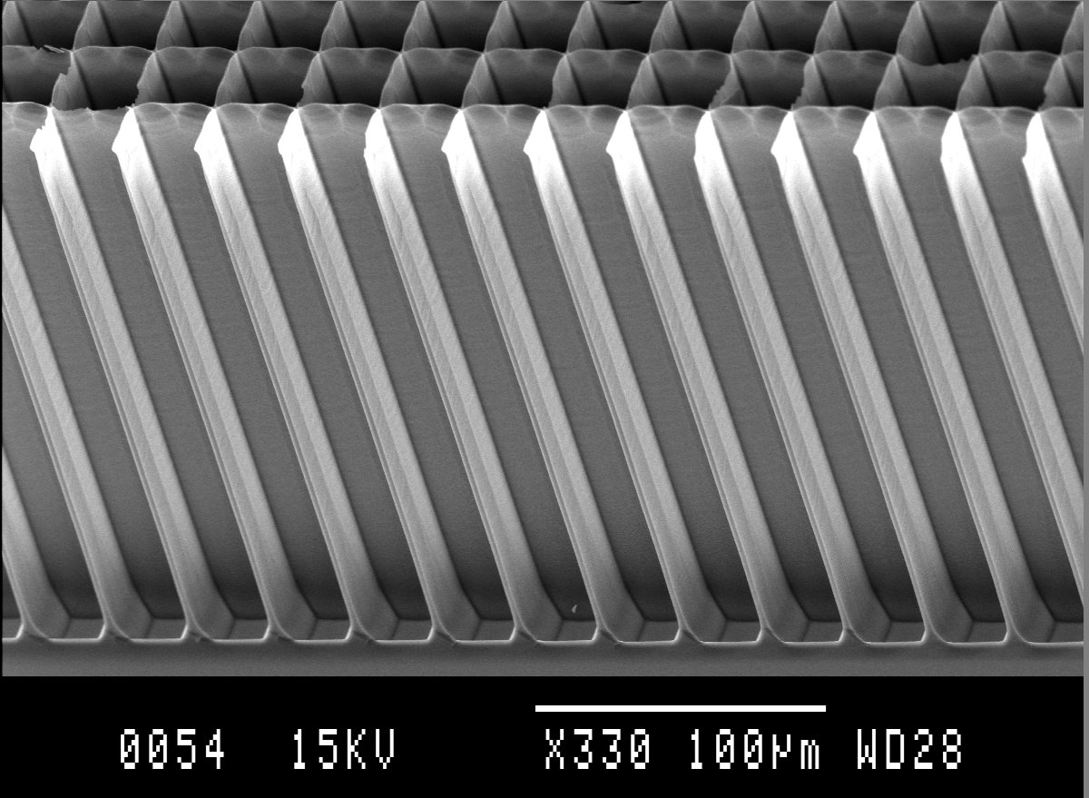
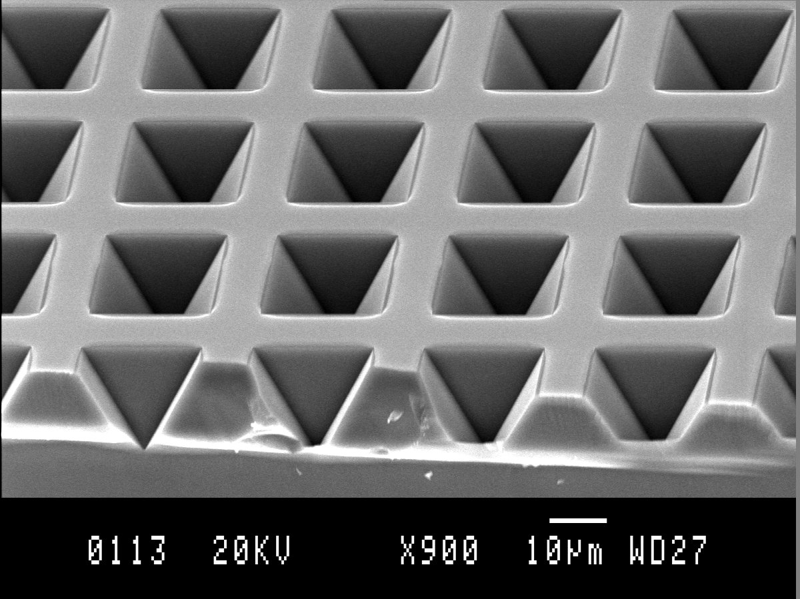
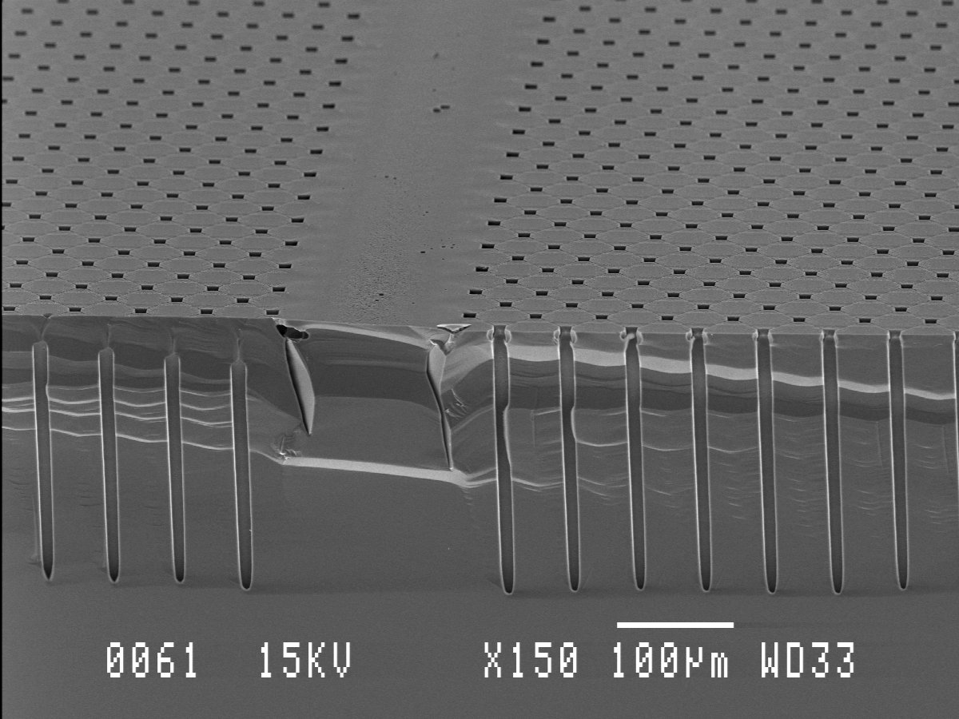
Figure 6. A schematic of the set-up for electrochemical etching is shown on the top left. The formation of the dimples with a KOH etch is shown underneath and the micrographs on the right show, uppermost, structures etched for filling with scintillator and thin drilled pore arrays beneath.

The processing implications for this process are that all the structures must be formed in one pass of the process as the field would be severely distorted for a second pass. A further limitation is that the distance between holes may not exceed so much depending on the hole diameter as there is a tendency for the created carriers to diffuse and emerge in unwanted locations which gives rise to spurious etching. On the other hand, there is no limitation to the depth of structures that may be made and so aspect ratios of 40:1 [5] and greater have been achieved. This process is highly suited to producing regular arrays of regular large pores with very narrow (4μm) walls that are ideally suited for the fabrication of scintillator filled light guides of arbitrary depth.

Laser Drilling
Finally Laser drilling has been used to real thin holes in GaAs as DRIE and EE both have difficulties in reaching the desired depth of etching for any interesting aspect ratios. Work in both of these areas is ongoing but the progress is slow. For the drilling a femto-second laser source is used as this will minimise the damage to the crystal due to thermal shock. The duration of the pulse is so shorter in comparison to any thermal diffusion that takes place at the ablated surface that there is no shock wave through the material. The laser is a Ti:Sapphire tuned to 400 nm giving 40 fs pulses of 3 mJ each with a 1 kHz frequency of repetition. The advantages of such a tool are that there is no sensitivity to the chemistry of the material to be drilled and very little damage to the crystal away from the hole. The disadvantages are that it is a serial process and will never be suitable for production of arrays with a high pixel count. In addition there is a slight taper to the holes (10 μm entry and 6 μm exit for a 200 μm thick GaAs substrate). In addition to this there is a small amount of debris evident near the holes after formation as shown in Figure 7.
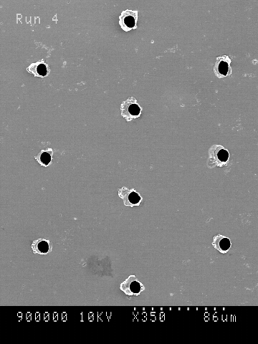
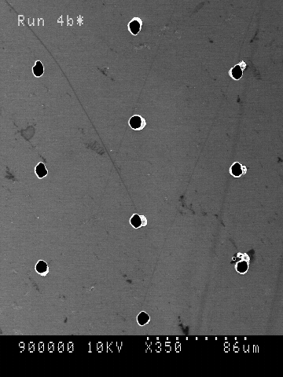
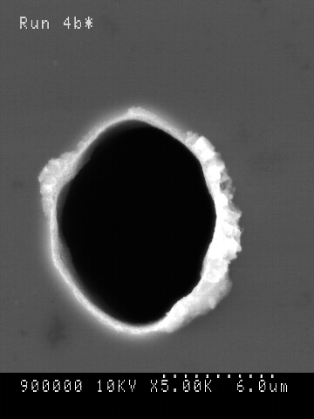
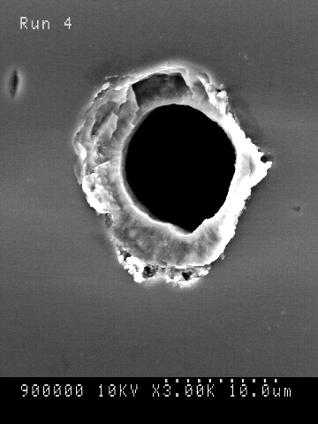

Figure 7. 10 μm laser drilled holes for an array of 85 μm pitch close packed hexagonal array of pixels and a close-up of the debris that is created around the holes during drilling. This is removed by a light chemical polishing prior to further processing.

Fabrication of Devices
The large hole structures have been filled with Thallium doped CsI from the melt using a variety of process cycles in order to optimise the fill and also the light output. It has been found that filling with the melt at minimal temperatures leads to incomplete filling of the structures. Examination after the fill shows the presence of a large number of voids in the material. Examinations of x-ray transmission and light output patterns show no particular correlation which unfortunately does not help in estimating the thallium loss during the fill. Increasing the melt temperature prior to filling and starting with an overdoping of thallium gives transmission and light output patterns that are very tightly correlated shown in Figure 8, indicating that the filling is not yet completely uniform but is greatly improved from initial attempts.
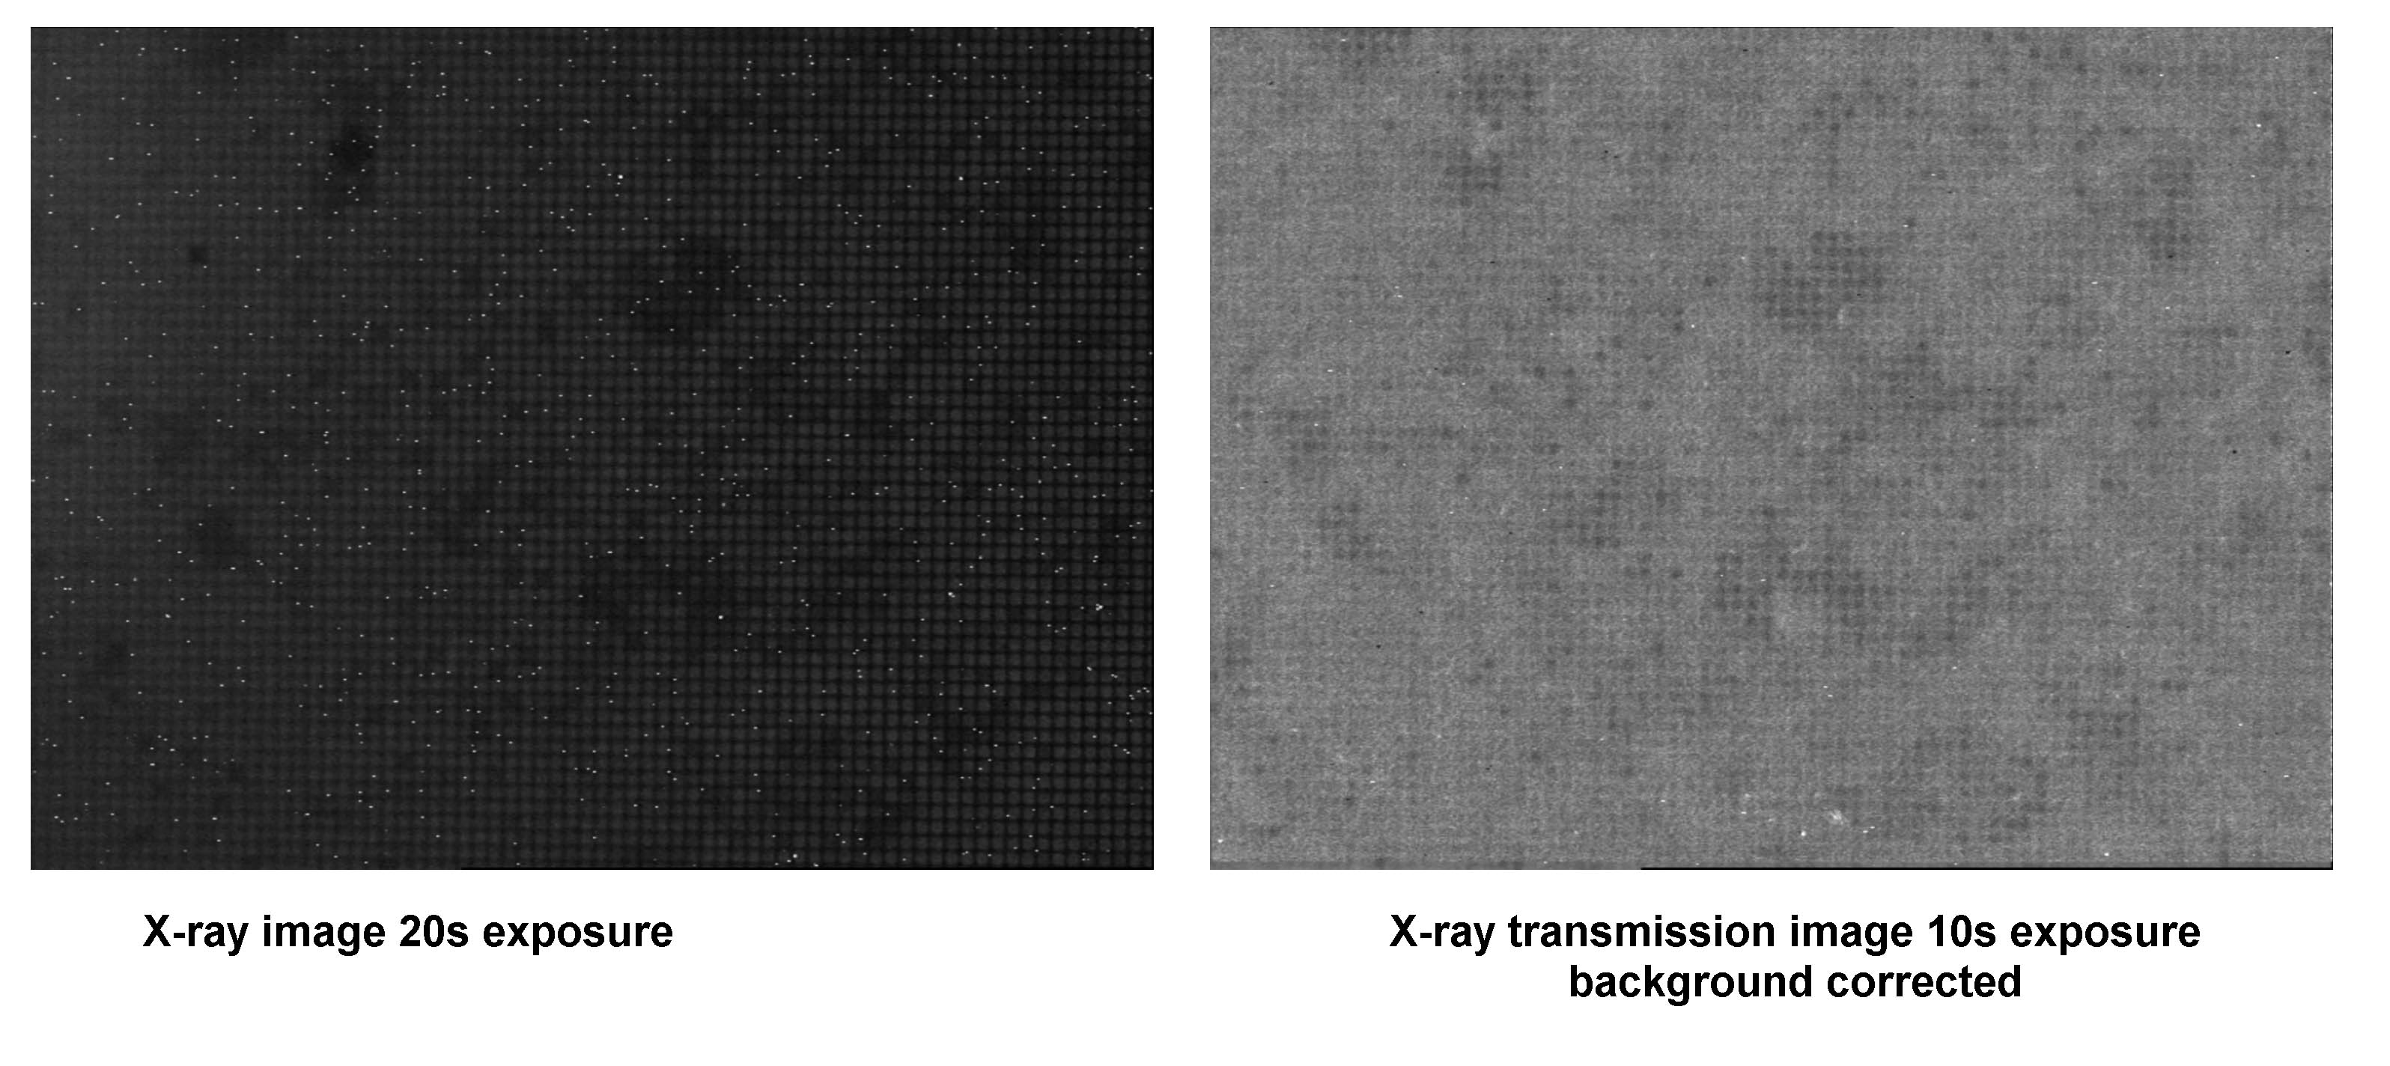
Figure 8. 45 μm pitch array of holes filled with CsI the depth of each pore is 400 μm deep. The red and green pointer show common feature in both pictures that lead one to conclude that filling may be more of a problem than light output uniformity.
X-ray Absorption

Light Output

Melt Filled (600ºC)

The light output of the structures may be increased significantly by a low temperature long term annealing cycle. This is currently under investigation as are means of improving the fill uniformity.
Laser drilled GaAs substrates have been metallised using evaporated Ti and electroplating Au through the back side of the wafer to form Schottky-Schottky based MSM structures as shown in Figure 9. The pixels are laid out in a close packed hexagonal pattern with 85 μm pitch on a substrate of GaAs 200 μm thick. A series of contact pads and side-wall electrode interconnections are deposited on the top surface before a layer of protective Si₃N₄ is deposited and apertures are opened through it for the electrical connections.

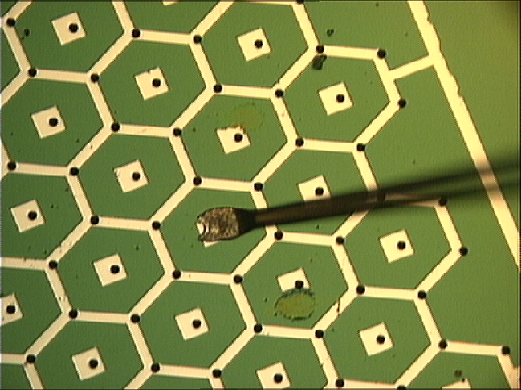

Figure 9. 85μm pixels on GaAs substrate material with laser ablated holes, the detector is 200 μm thick.

The detector has been coupled to a charge sensitive amplifier called the DASH-E designed at Rutherford Appleton Laboratories. This front end has very little tolerance for leakage current in the detector and seeing as these elements were quite leaky we were forced to cool the set-up to – 30 C in order for the electronics to function properly. When illuminated with a sealed ²⁴¹Am source, the spectrum shown in Figure 10 was obtained. The detector was biased at only 10 V for this data. We are currently modelling the peak height ratios with MCNP to determine the amount of material that is active in the pixel. It is also interesting to note that the low energy tail that is usually present in detectors made from Czochralsky material due to charge trapping is not present in this spectrum.

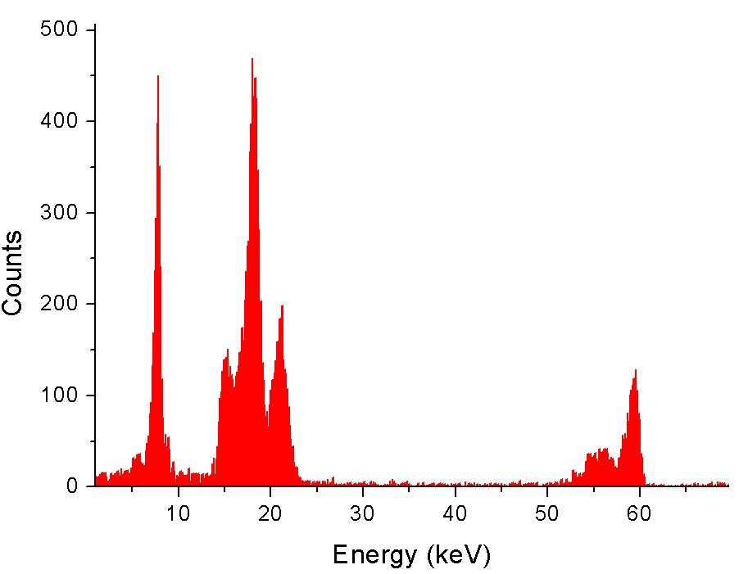
Figure 10. An ²⁴¹Am spectrum at 10 V bias and –30 C for a 3-D GaAs pixel detector element.

Conclusion
There is much more work to be done in the development of a reliable and reproducible process for the production of the types of device that it is hoped to realise in this development project. Prototype devices have produced results with device performance that encouraging and will provide the impetus for further development. Further work on the filling of holes and the development of a doping process for silicon is currently under way with the goal of prototyping 3-D detectors in this material.
References
- S.Parker et al, Nucl. Instr. And Meth. A 395 pp. 328-343(1997).
- http://www.cern.ch/medipix/
- CANDID and DEARMAMA -- EU FP5 projects in Quality of Life programme.
- J. Bhardwaj et al, Advances in High Rate Silicon and Oxide Etching using
ICP, MEMS/MST Technology Symposium at SEMICON West 99.
- X. Badel, PhD Thesis, KTH Stockholm, 2003.

* This work is supported by the European Commission FP5 GROWTH Programme, Project N° : G5RD-CT-2001-00536

