GLAS-PPE/2005-18
 | Department of Physics & Astronomy  Experimental Particle Physics Group  Kelvin Building, University of Glasgow  Glasgow, G12 8QQ, Scotland  Telephone: ++44 (0)141 339 8855 Fax: +44 (0)141 330 5881

Hybrid Photon Detectors for the LHCb RICH Counters

F.J.P. Soler
Department of Physics and Astronomy
University of Glasgow, Scotland
and CCLRC, Rutherford Appleton Laboratory, Chilton, Didcot, Oxfordshire, U.K.
Email: p.soler@physics.gla.ac.uk

On behalf of the LHCb Collaboration

Abstract

Hybrid Photon Detectors (HPD) have been chosen for the Ring Imaging Cherenkov (RICH) detectors of the LHCb experiment. Photons impinging on a multi-alkali S20 photo-cathode deposited on a quartz window produce photo-electrons that are accelerated by a 20 kV potential onto a silicon pixel sensor anode. The sensor is segmented into 8192 pixels of size 0.0625 mm  0.5 mm with an electronic OR forming 1024 super-pixels of 0.5 mm  0.5 mm. The cross-focusing electron optics introduces a demagnification factor of five, resulting in an effective pixel size of 2.5 mm  2.5 mm at the photo-cathode. The silicon sensor is bump-bonded to a pixel chip fabricated using 0.25 μm deep submicron radiation-tolerant technology, which amplifies and digitizes the anode signals at the LHC speed of 40 MHz. The sensor/chip assembly is mounted inside the HPD vacuum envelope. Mass production of 484 HPDs for the LHCb experiment has commenced in close collaboration with industry. Measurements of HPD properties in the laboratory are presented. These include supply currents, threshold scans, dark count, ion feed-back rates, quantum efficiency and image distortions due to magnetic fields. Finally, results from studies of the HPD performance for the detection of Cherenkov light produced in particle test beams are reported.

- Introduction
The LHCb experiment [1], which will make precision measurements of CP violation and rare decays from B mesons at the Large Hadron Collider (LHC), is currently being built at CERN. LHCb consists of a forward arm spectrometer designed to capture a significant fraction of the B decays from the interaction vertex (Fig. 1). A system for charged particle identification is essential to separate pions from kaons in the final state for selected B meson decays. Two Ring Imaging Cherenkov (RICH) detectors with three different radiator materials (aerogel, C₄F₁₀ and CF₄) will be used in LHCb to perform pion and kaon separation from 2 to 100 GeV/c [2]. The acceptance in the bending plane of the upstream RICH1 is from 25 to 300 mrad, while that of the downstream RICH2 is 15-120 mrad from the interaction vertex.
There are on average 31 photo-electrons (PE) per high momentum (saturated) well measured track reconstructed in C₄F₁₀, 6.8 PE/track in the aerogel (both in RICH1) and 23 PE/track in the CF₄ in RICH2. The resolution achieved is 1.6 mrad/PE, 2.6 mrad/PE and 0.7 mrad/PE for the C₄F₁₀, CF₄ and aerogel respectively. Position-sensitive photon detectors are needed to reconstruct the Cherenkov rings. Pixel Hybrid Photon Detectors (HPDs) have been chosen for the LHCb RICH [3]. A total of 484 HPDs are needed to cover the 2.6 m² total photon detection area (196 HPDs for RICH1 and 288 for RICH2).

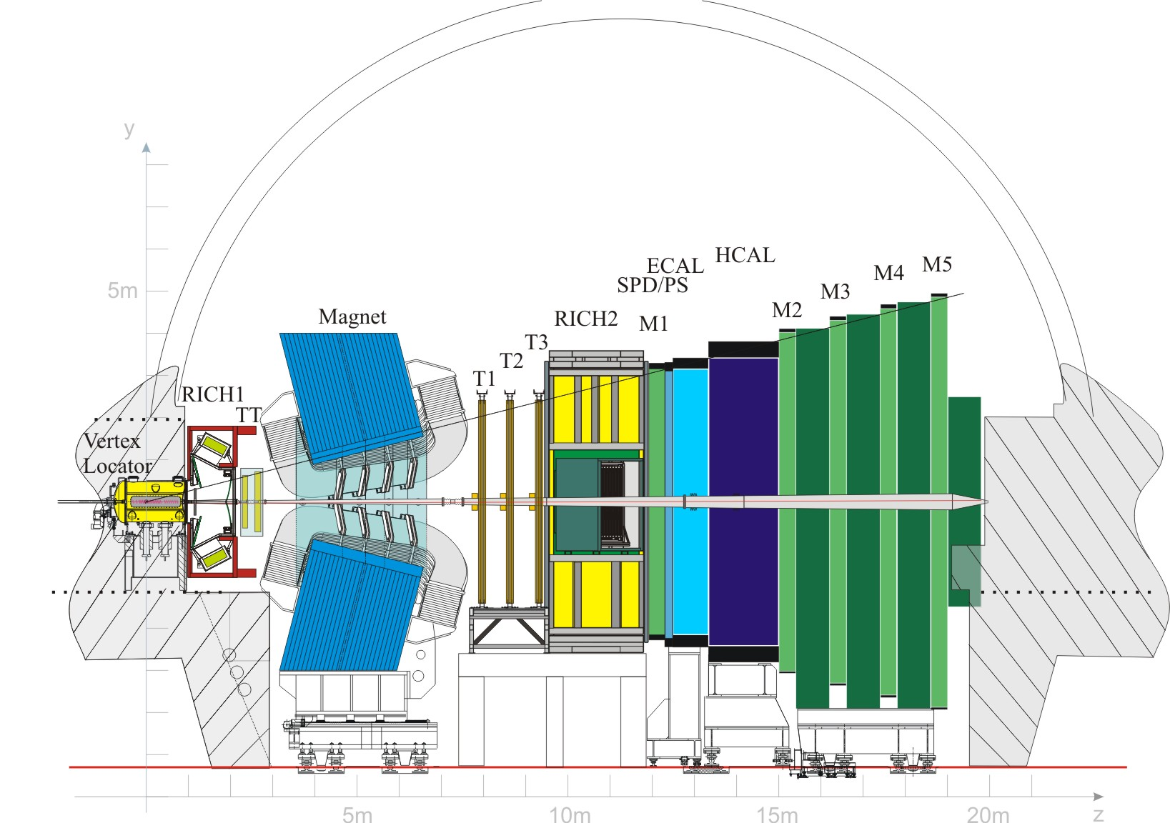

Fig. 1. Side view of the LHCb experiment.

- Hybrid Photon Detectors
The development of the pixel HPD has been carried out in close collaboration with industry. The HPD consists of a pixel silicon detector array bump-bonded to a custom-made pixel chip (collectively called the anode), encapsulated inside a vacuum tube, with an S20 multi-alkali photo-cathode (Fig. 2).

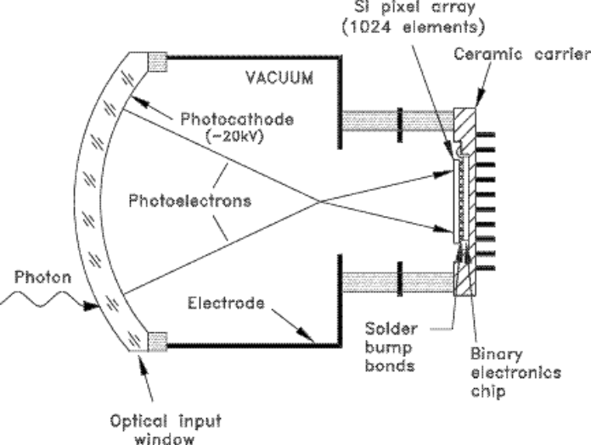

Fig. 2. Schematic of the HPD.

A photon incident on the 7 mm thick quartz window ejects a photo-electron at the photo-cathode, which is accelerated by a 20 kV potential, focused by using cross-focusing optics onto the anode assembly. The photo-cathode achieves 25% quantum efficiencies at 270 nm wavelength and is sensitive in the region from 200 nm to 700 nm. The integrated quantum efficiency (QE) requirement over the full photon energy (E) range is ∫QE dE > 0.7 eV. The HPD has a cathode of 83 mm in diameter (with a 75 mm active cathode diameter), and height of 124 mm.
The anode assembly consists of a Canberra [4] 32x256 (8192) pixel array, covering a 16x16 mm² active area, with reverse biased p-n junctions of 300 μm thickness bump-bonded onto the LHCBPIX1 binary readout chip [5]. The photo-electron signals observed consist of approximately 5000 electron-hole pairs. Each individual pixel has dimensions 62.5 μm  500 μm, but in normal operation of the pixel chip, internal logic makes a logical OR of the discriminator output of eight adjacent pixels in a column, forming super-pixels of dimensions 500 μm  500 μm. The cross-focusing optics introduces a demagnification factor of about 5, leaving an effective pixel size of 2.5 mm  2.5 mm at the photo-cathode surface. A simulation of the point spread function shows that the RMS position of an electron ejected at the photo-cathode onto the silicon plane is typically 97 μm, so usually all electrons from a given position are focused onto one super-pixel.
The LHCBPIX1 pixel readout chip is manufactured in commercial 0.25 μm CMOS technology, allowing operation in the radiation environment that they will encounter in LHCb of 3 kRad/year. Each channel on the chip consists of analogue and digital sections. The analogue part consists of a pre-amplifier, two shaper circuits and a discriminator with 3-bit threshold adjust. The digital part consists of a fast OR, delay units for signal buffering, a trigger strobe, a 4-event First-In-First-Out (FIFO) memory and a single-bit register which, together with the other pixels in the column, form a shift register to shift the data out of the column. The requirements of the pixel chip are such that it has to operate at the LHC speed of 40 MHz (25 ns precision), with low noise (less than 250 electrons) and low threshold (less than 2000 electrons) to be able to observe the 5000 electron signal.
Anode assemblies are manufactured by bump-bonding the Si pixel array to the pixel chip. Because the HPDs need to suffer a bake-out cycle at 300°C during the photo-cathode deposition and vacuum sealing phase of the assembly, the company VTT, Finland [6], has developed a new solder with high Pb content (10% Sn and 90% Pb) that has a melting point in excess of 300°C. This process yields more than 99% good bumps. The assembly of the sensor and pixel chip is then packaged into a ceramic carrier at HCM, France [7] to make up the anode for the HPD. The final HPDs are manufactured at Photonis-DEP, Netherlands [8]. The full production of 550 HPDs, at a rate of about 30 HPDs per month, has already commenced. In the following sections we will report on a number of quality assurance tests carried out at a test facility, on a first batch of pre-series tubes delivered by Photonis-DEP.
- Performance of pre-series HPD tubes
Nine pre-series tubes have been delivered by the manufacturer and these have been extensively tested. Dedicated runs illuminating the whole photo-cathode area with Light Emitting Diodes (LEDs) showed that more than 99.3% pixels were operational for all tubes except one that had one column missing. Threshold scans revealed threshold settings between 1103 and 1287 electrons, much smaller than the requirement of 2000 electrons, with a variation from pixel to pixel between 88 and 99 electrons and noise readings in the range 154 to 174 electrons.
Leakage currents from the silicon sensor were measured and all but one HPD had a leakage current that met the requirement of less than 1 μA at 80 V reverse bias voltage on the sensor (Fig. 3).
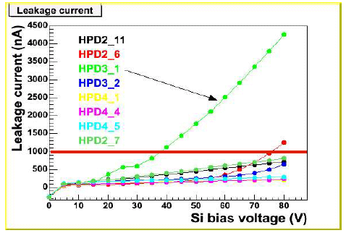

Fig. 3. Leakage current for nine pre-series HPDs.

Dark count rates were observed to stabilize after about 90-100 minutes after the high voltage was turned on. The stable rates measured were between 0.03 and 3.0 kHz/cm², which is below the requirement of less than 5 kHz/cm².
Photo-electrons can ionize residual gas molecules inside the vacuum. The ion produced can then travel back to the cathode and generate photo-electrons, about 200 ns after the first electron pulse. Ion feedback rates are a measure of the vacuum quality. The ion feedback rates measured were always less than 0.1% of the signal, much smaller than the 1% requirement.
The quantum efficiency of the 9 tubes is shown in Fig. 4, with the minimum requirements shown as the lower set of crosses. It can be observed that all but one tube satisfy the requirements. However, the tube with lower efficiency in the ultra-violet has enhanced efficiency in the red and is also a good working tube, so could still be used in the LHCb RICH.
HPD performance is affected by magnetic fields due to the cross-focusing optics of the photo-electrons. A field transverse to the HPD axis can cause the electron trajectories to bend, while a field parallel to the axis of the HPD rotates the electron trajectories around this axis. Mu-metal cylinders will be used on each individual HPD to shield them from fields up to 25 Gauss in RICH1 and 8 Gauss in RICH2. Test patterns are used to parameterize the distortions. There is no loss of active area if the field is less than 30 Gauss and the typical electron rotation for this field is about 0.7 rad. The parameterization is well understood for both transverse and axial fields.
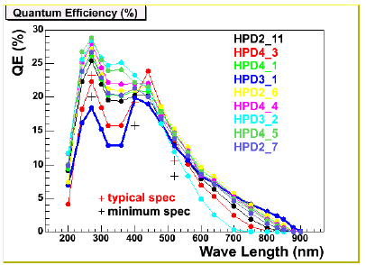

Fig. 4. Quantum efficiency curves for the nine pre-series HPDs.

- Test beam
A test beam data-taking run took place in November 2004 in the T9 area of the CERN PS. The beam delivered 10 GeV/c pions and electrons onto a vessel containing a radiator gas and a spherical mirror for focusing the light onto a plane consisting of six closely packed HPDs. With N₂ as the radiator gas, Cherenkov rings were fully contained inside individual HPDs and very good separation for pions and electrons was observed. The measured Cherenkov angles agree with the expectation of 19.1 mrad for pions and 23.7 mrad for electrons. Clear Cherenkov rings were observed across the six HPDs when the radiator gas was C₄F₁₀ (Fig. 5).

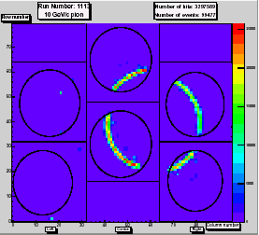

Fig. 5. Accumulation of individual Cherenkov rings on 6 HPDs from a particle test beam run at the PS at CERN.

- Conclusions
Hybrid Photon Detectors (HPD) will be used for the RICH counters of LHCb. The HPDs are meeting the experimental requirements and are performing as expected. A production of 550 HPDs is underway. Quality assurance shall be provided by the manufacturer and at dedicated test facilities that have to meet the production rate of about 30 HPDs/month. A test beam run carried out in November 2004 validated the laboratory results and demonstrated that the HPDs can be used to measure the angle of the cone of Cherenkov light.
Acknowledgments
We wish to thank all our colleagues who have provided technical support and the PS and SL Departments for operating the T9 test beam. This research is supported by CERN, Istituto Nazionale de Fisica Nucleare (INFN, Italy) and the Particle Physics and Astronomy Research Council (PPARC, UK).
References
- The LHCb Collaboration, LHCb Re-Optimized Detector Design and Performance Technical Design Report, CERN/LHCC 2003-030, LHCb TDR9, 9 September 2003.
- The LHCb Collaboration, LHCb RICH Technical Design Report, CERN/LHCC 2000-037, LHCb TDR3, 7 September 2000.
- T. Gys, Nucl. Instr. and Meth. A 465 (2001), 240.
- Canberra Semiconductor, N.V. Lammerdries 25, B-2250, Olen, Belgium.
- K. Wyllie et al., Nucl. Instr. and Meth. A 546 (2005), 86-92.
- VTT Information technology, P.O. Box 1200, FIN-02044, Finland.
- Hybritech Composants Microélectroniques, ZI de Périgny, Av. Joliot-Curie, F-17185, Perigny,France.
http://www.hcm-france.com/.
- Photonis-DEP BV, NL-9300 AB Roden, Netherlands.

